Assembly of a Four Point Probe that Operates under the Van der Pauw Method
L. Kojovic
¹⁾ McMaster University, 1280 Main Street West, Hamilton, ON, Canada.
(Dated: 20 November, 2016)
Abstract
The purpose of this experiment was to create a four point probe that would be able to take sheet resistance measurements in a lab setting. These results were then compared to an inline four point probe. The probe was assembled and was able to take successful sheet resistance measurements once in five attempts. The successful sheet resistance measurements of 29.23 Ω/□ did not match the measurements taken from the inline four point probe of 9.889 Ω/□. However, improvements to the four point probe were suggested and these improvements can be made next time in order to assemble a more consistent and efficient four point probe.

PACS numbers:
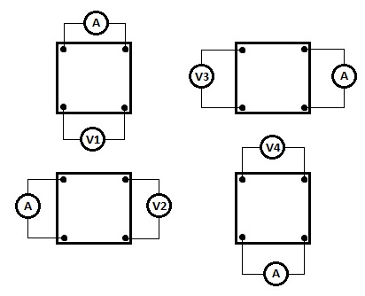
Keywords: Four point probe, Van der Pauw

I. Introduction
We will be describing how a four point probe was developed in the lab in order to take sheet resistance measurements of Indium Tin Oxide (ITO). With these measurements we will explain what other information can be attained from them. However, first off we will discuss the history of the four point probe and then move onto its applications in the semiconductor industry.
The four point probe was first developed by Frank Wenner in 1915 in order to measure the earth’s resistivity. He hoped to use these measurements to help find certain characteristics of the region’s composition, for example, moisture content, or ore of high conductivity ^{[1]}. It was in 1954 that L.B. Valdes used the four point probe to measure the sheet resistance of germanium ^{[2]}. This event sparked the use of the four point probe in the semiconductor industry and it has become one of the simplest and most effective ways to measure the sheet resistance.
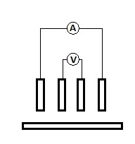
The four point probe works by having a current being run through two of the probes and then having a voltage being read by the other two probes. Fig. 1 and Fig. 2 demonstrate the two main methods of the four point probe; inline and Van der Pauw method, respectively.

Fig. 1 Diagram of the inline method ^{[3]}. Shows what vertical pins have a current running through them and what vertical pins read the voltage drop. The bottom rectangle is the substrate. All pins are equally spaced from each other.

Fig. 2 Diagram of the Van der Pauw method ^{[4]}. Shows four orientations and what pins have the current running through them and what pins read the voltage drop.

Both these methods can be used to find the sheet resistance and in the end they produce the same results. However, the inline method is simpler as it only requires one measurement to be performed, whereas the Van der Pauw method requires four measurements to be done at different orientations and then these values are used to find the sheet resistance at each orientation. They are then averaged out to find the final sheet resistance. Equation (1) ^{[5]} shows the formula used in order to get the sheet resistance for the inline method, and Equation (2) ^{[4]} shows the formula used to get the sheet resistance using the Van der Pauw method.

$$R_{s}=RCF\left(\frac{V}{I}\right) \left(1\right) \\ R_{s}=\left(\frac{п}{\ln\left(2\right)}\right)*\left(\frac{V}{I}\right) \left(2\right)$$

Where, RCF is the resistivity conversion factor, V is the voltage, and I is the current.

With the sheet resistance now known, you can find the resistivity using Equation (3) ^{[6]}.

$$R_{s}=\left(\frac{ρ}{T}\right) \left(3\right)$$
Where T is the sample thickness, ρ is the resistivity, and R_{s} is the sheet resistance.

Now with the resistivity value found, you can use it to find various parameters of the semiconductor material. One parameter that is usually calculated using the sheet resistance is the doping concentration of the semiconductor material and another one is the mobility of the semiconductor ^{[6]}.

II. EXPERIMENTAL
In this experiment a Van der Pauw method four point probe was created. Its sheet resistance results were compared to the results of a Resistivity Test Rig, Model A, A and M Fellow Ltd. inline four point probe. An image of the assembled probe station can be seen in Fig. 3.
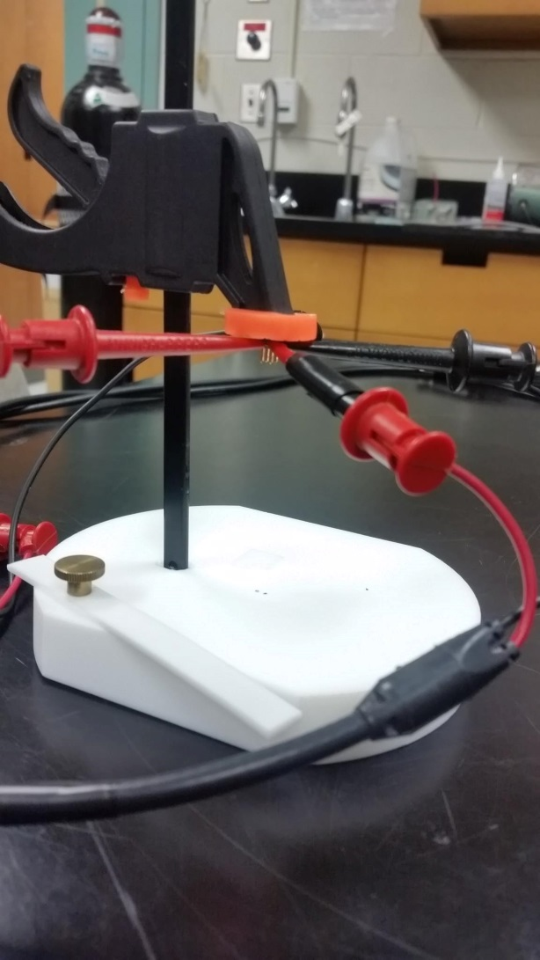

Fig. 3 Image of the Assembled Four Point Probe Station.

The four point probe head was created using four evenly spaced brass contact pins arranged in a square formation. The pins were spaced 5 mm apart. The pins were attached to a plastic vice with duct tape and super glue. The vice was mounted onto a Teflon stage, where the ITO substrate would be placed to have its sheet resistance measured. The pin heads where hooked up to an Xrtalien X100 Source Measurement Unit (SMU) by putting the SMU’s leads at the base of the pins. The pins would then be lowered until they made contact with the substrate. Once contact had been made, the SMU would send a current to two pins and then measure a voltage from the other two pins. The SMU was controlled with MATLAB R2012 and the code can be found on the Ossila Electronics Website ^{[7]}. This measurement was repeated for four orientations (V1,V2,V3,V4) as seen in Fig. 2. The measurement were then used to calculate the sheet resistance of the ITO using Equation (2) and taking the average. Once the results were obtained, they were then compared to the results taken of the same substrate using the inline method four point probe.

III. RESULTS

The results for the inline probe are shown in Table I. The RCF was taken to be 3.1041 due to the shape of the sampled ITO substrate ^{[8]}.

Table I Inline method sheet resistance results.
 | Voltage (mV) | Current (mA) | Sheet Resistance (Ω/□)
Trial 1 | 107.6 | 34.00 | 9.823
Trial 2 | 163.0 | 51.3 | 9.863
Trial 3 | 207.7 | 65.0 | 9.919
Trial 4 | 247.7 | 77.3 | 9.950
Average |  |  | 9.889

The results for the Van der Pauw probe are shown in Table II. The results were taken in four orientations in the same spot as the inline method was.

Table II Van der Pauw method sheet resistance results.
 | Voltage (mV) | Current (mA) | Sheet Resistance (Ω/□)
Orientation 1 | 10.98 | 1.761 | 28.24
Orientation 2 | 10.37 | 1.638 | 28.67
Orientation 3 | 11.08 | 1.754 | 28.62
Orientation 4 | 11.90 | 1.717 | 31.39
Average |  |  | 29.23

It is worth noting that the assembled probes success rate in measuring any values at all was very sporadic. The assembled probe was used five times to measure the sheet resistance of the ITO substrate and it only produced acceptable results one out of the five times. The other times it produced values of 1 ±.001 V for voltage and current measurements to the magnitude of 10⁻⁷ A.

IV. DISCUSSION
We can see that when comparing the sheet resistance from the assembled Van der Pauw four point probe (29.23 Ω/□) and the inline method four point probe (9.889 Ω/□) that the two do not agree with each other. This may be due to some inner resistance in the assembled probe, which gives it an offset. This could easily be solved by comparing it to an accurate probe, as we’ve done in this case, and calibrating the sheet resistance measurements accordingly. However, as noted in the results section the assembled probe was not reliable. It was only able to produce acceptable results 20% of the time.
A way to improve the probe would be to add pogo pins, instead of using solid pins. Pogo pins are pins that have a spring added into their structure. This allows them to retract when coming into contact with the substrate. This is an advantage, as it stops the pins from penetrating past the ITO layer, and just lets them sit on top of it, making enough contact to send an electrical signal. This penetration of the ITO layer could’ve been the reason for the inconsistencies in our results. The pogo pins could also help get rid of any contact resistance that was experienced. This contact resistance could’ve lead to high resistance, which would give us low current measurements on the order of 10⁻⁷ A as seen in section III.
It was also suggested that perhaps the readings weren’t consistent due to an internal resistance problem with the SMU. However, this idea was put to rest when the SMU leads were connected to a resistor and current and voltage measurements were taken. The resistance value calculated from the voltage and current readings matched the resistor, showing that the internal resistance was negligible.
Lastly, it was suggested that perhaps the ITO substrate was just worn out when the other four failed measurements were made. This was checked by bringing the substrate back to the inline probe and repeating the measurements. However, it was noted that after two trials on the inline probe we were getting results consistent with the ones from the first set of trials with the inline method. This meant that the ITO substrate had not been damaged or worn out.
V. CONCLUSIONS
In conclusion, a four point probe was assembled that performed using the Van der Pauw method. It was able to take voltage and current measurements of an ITO substrate once out of five attempts, which lead to a sheet resistance measurement of 29.23 Ω/□. This sheet resistance did not match the sheet resistance measured with the inline probe of 9.889 Ω/□. The inefficiency of retrieving practical results was most likely due to the fact that there was contact resistance between the substrate and the probe head in the assembled Van der Pauw probe. This contact resistance can be solved for by using pogo pins instead of the solid pin heads that were used, as it would allow for good contact to be made evenly with each of the probes.
VI. ACKNOWLEDGEMENTS
L.K. wishes to thank Dr. Ayse Turak and all members of the Organic Electronics Research Group for their help during the research of the four point probe. L.K. also wishes to thank Doris Stevanovic and Shahram Tavakoli for the use of their Resistivity Test Rig, Model A, A and M Fellow Ltd. inline four point probe.
VII. REFERENCES
^{[1]} F. Wenner, Bull. Bur. Stan. 12, 469 (1918).
^{[2]} L.B. Valdes, Proc. IRE 42, 420 (1954).
^{[3]} A. Shimamato, K. Yamashita, H.Inoue, S. Yang. M. Iwata, N. Ike, Press. Vess. Tech. 135, 21501 (2013).
^{[4]} P. Lienerth, Ph.D. Thesis, Institute of Theoretical and Applied Physics of the University of Stuttgart, Stuttgart, 2009.
^{[5]} A.P. Schuetze, W. Lewis, C. Brown, W.J. Geerts, Amer. Jour. Phys. 72, 149 (2004).
^{[6]} A. Kitai, Principles of Solar Cells, LEDs and Diodes (Wiley, Chichester, 2011) p. 190.
^{[7]} https://www.ossila.com/pages/xtralien-x100-source-measure-unit-getting-started (last accessed November 25, 2016).
^{[8]} F.M. Smits, Bell Sys. 37, 711 (1958).

