Identification of an Unknown Material Through Gamma Ray Detection
Daniel Wilding¹
¹⁾ McMaster University, 1280 Main St W, Hamilton, Canada

(Dated: 23 NOVEMBER 2016)
Gamma rays and X-ray photons can interact with matter in three distinct ways. Dependent on the energy of the photon in question, Compton scattering, pair production, and the photoelectric effect can all occur. In this lab, through the use of energy dispersive spectrometers the operation of gamma ray detectors was analyzed. Through the use of a Sodium Iodide (NaI) detector, the spectrums of a Cobalt-60 source were collected as data. These spectrums changed for varying distances from the detector as well as the length of time used for source detection. Finally, bipolar pulses were used to compensate for undershoot and give a different perspective of the spectrum. Through the use of a Germanium Detector, the spectrum of Cobalt-60 was once again acquired with the addition of Cobalt-57. This was done as to calibrate the Multi-Channel Analyzer for energy versus channel number. A new spectrum from an unknown source was then acquired and using the previous calibration a hypothesis of Manganese-54 was chosen as the known source with a peak energy of 833.38 keV.
23.20.Ra 25.20.Dc, 29.40.Mc
Keywords: Gamma Ray, Detection, Spectroscopy, Multi-Channel Analyzer, Germanium, Sodium Iodide, Scintillation.

I. Gamma ray and x-ray interaction with matter
Gamma ray detection is the measured results of gamma ray interactions with matter. There are three distinct mechanisms in which this can occur; Compton scattering, pair production, and the photoelectric effect,. Compton scattering occurs when the gamma ray collides with an electron causing an inelastic collision to occur as the electron absorbs some of the gamma energy. If both the electron and the scattered photon can be detected then the initial gamma energy can be inferred. Pair production occurs when the photon passes in close proximity to the nucleus causing the creation of an electron-positron pair. This electron-positron pair will eventually collide annihilating each other and creating a photon pair that can easily be detected to infer the gamma energy. The photoelectric effect is essentially the process that occurs when an atom absorbs a photon, in this case a gamma ray, and consequently emits an electron. [1] [2]

A. Compton Scattering
Compton Scattering is an example of the phenomenon of inelastic scattering. It occurs when a photon of a certain wavelength (in this case a gamma ray or X-ray) interacts with a free electron or a weakly bound electron, transferring part of its energy and being ‘scattered” at a new angle with a new wavelength. The electron leaving the collision will often have energy very close to that of the lost energy of the gamma ray due to the minuscule value of binding energy of the electron in comparison to that of the gamma ray. The production of the scattered gamma ray and the released electron, when both detected can result in the initial gamma ray energy can be calculated. Compton Scattering is considered the mid-energy level of light interaction with matter.[3]

B. Pair Production

When a gamma ray has a certain energy, in the range of 1.022 MeV or greater, and is placed under an electromagnetic field of certain strength it can create an electron positron pair. This must occur near a nucleus to conserve momentum and energy. The gamma ray peaks are detected in the measured spectrum when the positron runs out of energy and collides with the electron in an annihilating interaction. This occurrence allows for the collection and measurement of gamma ray energy peaks in the spectrum. Pair Production is considered the high energy level of light interaction with matter.[3]

C. Photoelectric Effect

The photoelectric effect is the lowest energy of light interaction with matter. Since this scenario occurs at such a low energy, the incident photon (gamma ray or x-ray) is of approximately equal or just greater value in energy to that of the electron binding energy. This causes an interaction in which the electron is freed at the cost of the whole gamma ray. The released photoelectron will have an energy equalling the value of the difference between the energy of gamma ray and the electron binding. A detector can acquire the total energy pulse of the gamma ray by receiving the freed photoelectron as well as various emitted x-rays that make up the electron binding energy. [3]

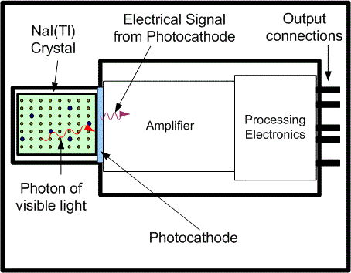
Fig 1: A Sodium Iodide Detector contains a NaI crystal, which takes the incoming gamma ray and turns it into visible light. The photocathode turns this into an electrical signal, which is amplified and then sent to processing electronics like the Multi-Channel Analyzer.
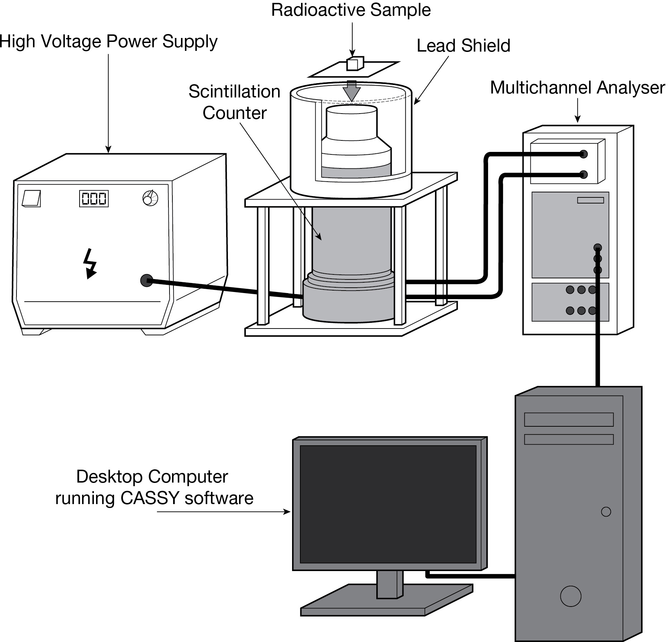

Fig 2: A Multi-Channel Analyzer Spectroscopy detection system.
II. Multi-Channel Analyzer (MCA)
Multi-Channel Analyzers are tools used to produce data from various scientific measurements. Multi-Channel Analyzers take the input voltage pulses from the amplified electric signals and organize them into a readable graph or spectrum. This spectrum is the number of events versus pulse-height. This spectrum can be used to gather data, including the Full Width Half Maximum, the integrated peak width at the Full Width Half Maximum, the gross integral, the centroid and the peak count. These various measurements can be used to interpret the understanding of how distance, gain, and bipolar pulses affect the results of gamma spectroscopy. The Multi-Channel Analyzer and Detector experiment can be set up as pictured in Figure 2 [5].
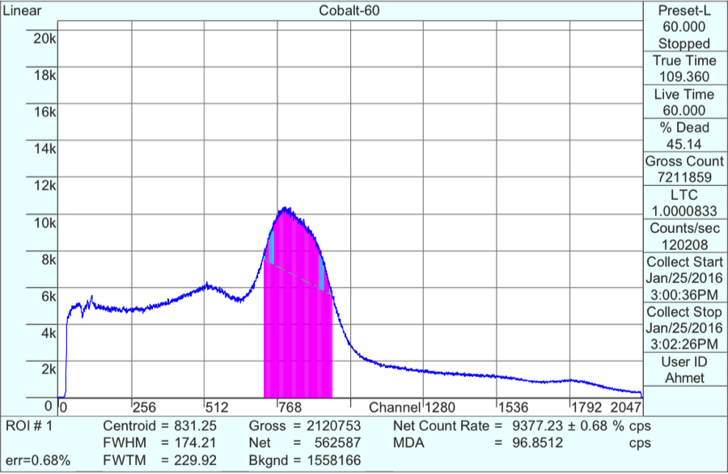

Fig 3: The spectrum acquired from a Cobalt-60 source at a distance of 0 cm.
III. SPECTRUM ANALYSIS WITH A Sodium Iodide Detector
The Sodium Iodide Detector, which is an example of a Scintillator detector system, is highly efficient in gamma detection. Due to the high Z of iodine and the consequent large number of electrons to interact with Sodium Iodide detectors make excellent scintillation detectors. They are a cheaper option when it comes to detecting equipment but are generally only good for spectrometry. An example of the cross section of a Sodium Iodide Detector can be seen in Figure 1[1][4][6][9].
A. COBALT-60
For this experiment, a Cobalt 60 source was used to test the features of the Sodium Iodide Detector and to discover some pros and cons as well as come to any conclusions about this method of radiation detection. Several tests were undertaken at varying distances and at full and half gain. As an example, shown in Figure 3, a Cobalt-60 source was measured at 0cm away from the detector resulting in the spectrum shown through the Multi-Channel Analyzer.

Table I A collection of data from the Sodium Iodide Detector Results.
Test Description | Centroid | Full Width Half Maximum | Gross Integral | Time (s)
Cobalt 60 0cm | 831.25 | 237 counts | 2120753 | 60
Half Gain | 418.59 | 118 counts | 2104840 | 60
5s Full Gain | 834.46 | 237 counts | 176290 | 5
2cm Peak 1 | 859.48 | 77 counts | 453874 | 60
2cm Peak 2 | 992.54 | 107 counts | 462575 | 60
4cm Peak 1 | 884.67 | 83 counts | 298791 | 60
4cm Peak 2 | 1020.33 | 86 counts | 254499 | 60
Bipolar 4cm Peak 1 | 969.38 | 75 counts | 285222 | 60
Bipolar 4cm Peak 2 | 1106.73 | 89 counts | 270493 | 60
Bipolar 0cm Peak 1 | 951.92 | 73 counts | 804021 | 60
Bipolar 0cm Peak 2 | 1090.77 | 86 counts | 755185 | 60

B. Sodium Iodide Detector Results
Table I shows the large range of values gathered from the Multi-Channel Analyzer through the Sodium Iodide Detector. A low Full Width Half Maximum value relates to radiation peaks with a higher resolution. As can clearly be seen from Table I, the bipolar pulses produced the best resolved peaks. As the order of magnitude of the peak count was maintained the bipolar pulse method returned relatively lower full width half maximum values. A better resolution allows for the energy band of the peak to be more accurately calculated. Unipolar pulses could have possibly left charge on the capacitors resulting in errors for the pulses occurring one after the other.
Therefore as can be seen the Sodium Iodide detector yielded results of less than excellent calibre. For the Sodium Iodide detector to produce reliable results a large quantity of trials needs to be conducted over a larger amount of time. As can be seen the 5 seconds trial in Table I produced results of a very poor resolution.
Another point worth mentioning is the differences found in resolution between the different distances at which the Cobalt-60 source was placed. At 0 cm the resolution was not very good. At 2cm it was significantly better and at 4 cm the resolution had decreased again. It would make sense for the resolution to be better when the source was closer. For 0cm however, the source is saturating the detector at peak energy levels creating an element of significant error. [6][9]

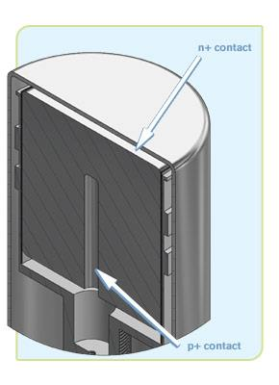
Fig 4: Cross Section of a Germanium Detector
IV. SPECTRUM ANALYSIS WITH A GERMANIUM DETECTOR
Semiconductor detectors like the Germanium Detector operate by knowing that the incident gamma ray will enable an electron-hole pair to be created in PN junction of the semiconductor. By applying a high biased voltage the electrons that have been freed will move to the P or the N side where they will be detected.
The Germanium Detector is much more efficient at returning a much better resolution. While being more expensive the Germanium Detector due to their liquid nitrogen cooling system they have a much lower formation energy per electron whole pair in comparison with the Scintillation detector.
Another key factor is that Germanium Detectors have little to no dead time. Dead time is the delay between the detection and the signal being fully processed.
The Germanium Detector was chosen for the calibration of a curve from gathering the spectrums of Cobalt-60 and Cobalt-57. The calibrated curve was then used to analyze the unknown sample and conclude on its nature [6][7].

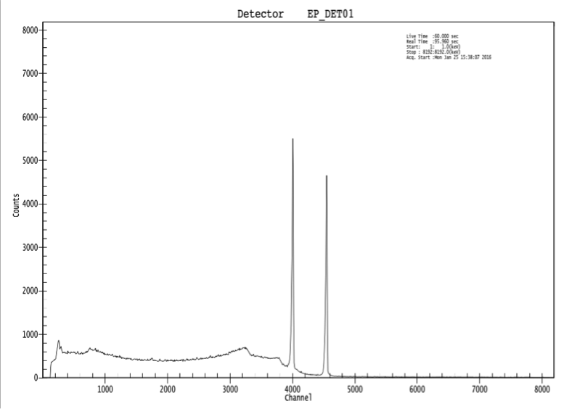
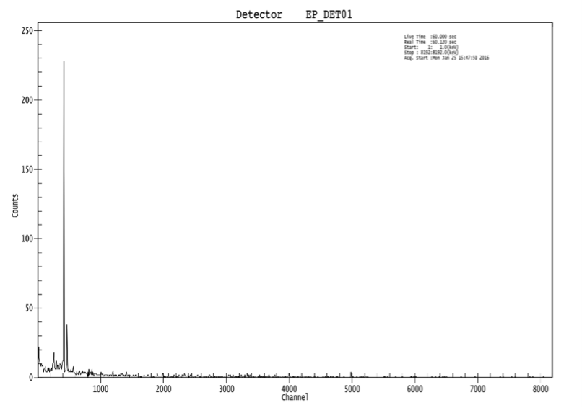
Fig. 5 Measured spectrum of a Cobalt-60 source with the Germanium Detector

Fig 6: Measure spectrum of a Cobalt-57 source with the Germanium Detector
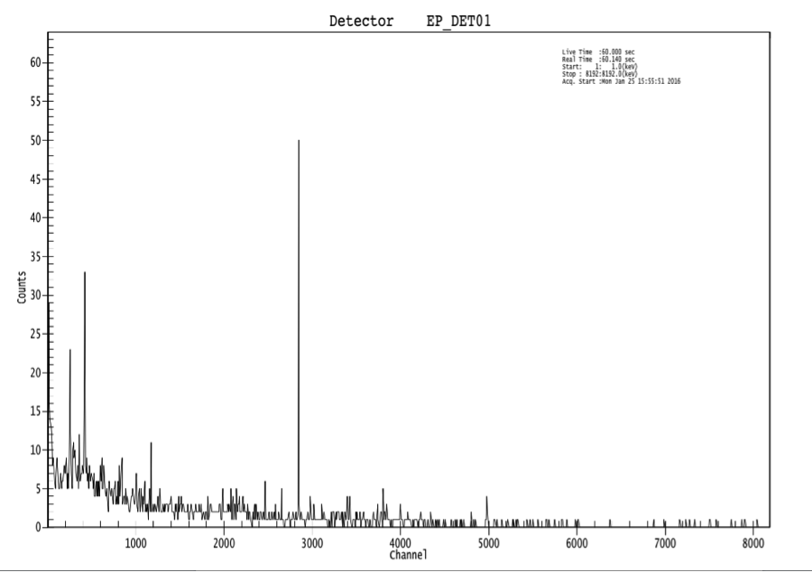
Fig. 7 Measured spectrum of an unknown source with the Germanium Detector

Source | Channel # | Peak Significance | Energy
Co-60 | 4006.23 | 84.67 | 1173.24
Co-60 | 4549.39 | 82.91 | 1332.5
Co-57 | 416.45 | 22.89 | 122.06
Unknown | 2844.98 | 14.21 | N/A
Table II Data collected from the Germanium Detector Spectra

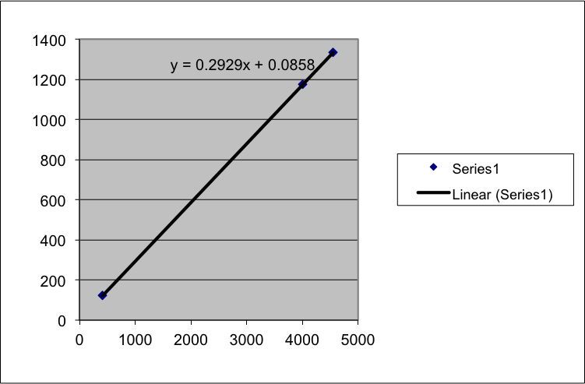

Fig 8: A plot of channel number versus energy
A. Unknown Isotope Analysis
The data collected from the germanium detector was presented on the Multi-Channel Analyzer and the spectra of the two known sources and the unknown sources were plotted and can be found above in Figure 5, 6, and 7. Table II shows the important data from the spectra clearly. The energy column was found by taking the peak significance from the known sample isotopes, and finding their well-known corresponding energies [8].
Using simple algebra and the calculation of the slope from the table of spectra values the following equation can be formed.

$$Energy= 0.2929\left(Ch\#\right)+0.0858$$

Using the channel number of the unknown isotope, the energy of the unknown isotope can be calculated and a educated guess based on the known Gamma Ray Energy Peaks. The unknown isotope was found to be that of Manganese-54 which has one peak of 99.976% intensity and an energy of 883.38 keV [8].
V. CONCLUSIONS
Both distance and time effect how gamma rays travel and how well they are received. Over large amounts of time and many trials Sodium Iodide Detectors are excellent equipment for isotope analysis. Germanium Detectors are much more effective, accurate and resolute machines for analyzing the spectra of nuclear isotopes. If a calibration curve of previous sources is undertaken, an unknown isotope can be measured and determined with surprising accuracy. Through the measurement of Cobalt-60 and Coblat-57, an unknown source was determined to be Manganese-54 with a peak energy of 883.38 keV. The source must be close enough as well as sufficiently far away to avoid saturation of the gamma ray. Lastly, bipolar pulses produce much higher resolution than that of unipolar pulses.

Notes and references
[1] Department of Physics, Middlebury College, Gamma Ray Spectroscopy with NaI and Ge(Li) Detectors, 1992, http://cat.middlebury.edu/~PHManual/gamma.html, Accessed: February 7, 2009

[2] G. F. Knoll, Radiation Detection and Measurement (John Wiley& Sons, New York, 1979).

[3] Nelson, G., & Reilly, D. (1991). Gamma-ray interactions with matter. Passive Nondestructive Analysis of Nuclear Materials, Los Alamos National Laboratory, NUREG/CR-5550, LAUR-90-732, 27-42.

[4] Sodium Iodide Detectors. (2010). Retrieved November 23, 2016, from http://www.hc-sc.gc.ca/ewh-semt/contaminants/radiation/surveill/sodium-eng.php

[5] Multi-Channel Analyzer. (2011, December 03). Retrieved November 23, 2016, from https://upload.wikimedia.org/wikipedia/commons/a/ac/Scintillation_counter_as_a_spectrometer.jpg

[6] Weisshaar, Dirk. "Gamma-ray Spectroscopy: An Introduction." Michigan State University, 2011. Web. 23 Nov. 2016.

[7] "High-purity Germanium (HPGe) Detectors." High-purity Germanium (HPGe) Detectors - CANBERRA Industries. N.p., n.d. Web. 23 Nov. 2016.

[8] "se." Sympatico. N.p., 22 Jan. 2014. Web. 23 Nov. 2016.

[9] Second Year Laboratory - University of Sheffield. (n.d.). Retrieved November 23, 2016, from https://www.sheffield.ac.uk/polopoly_fs/1.14263!/file/N1.pdf

