Comparison of Methods for Increasing Heat Transfer in Steam Generators in a CANDU Reactor using various forms of Twisted Tapes
J.Racette¹⁾
¹⁾ McMaster University, Department of Engineering Physics, Hamilton, Ontario, Canada, L8S 4L7.
(Dated: 27 November 2016)
The efficiency of a reactor can be improved through an increase of heat transfer in the steam generator component of the heat transport system. To increase the amount of heat transfer possible, the Nusselt (Nu) number should be increased. Following the Reynolds analogy as well as the turbulence of fluid will also play a factor in heat transfer. Multiple twisted tape inserts were compared as these begin to increase turbulence in the flow. The twisted tapes come in multiple configurations and as such, have different performance abilities based on flow turbulence, which is governed by the Reynolds number (Re), and the geometry of the tape. With the conditions tested below, the helical twisted tape returned a larger Nu number at higher Re numbers. At the lower end of the spectrum, the dual twisted tape insert and the clockwise/counter-clockwise tape returned the largest Nu value.
PACS numbers: 28.41.Fr, 28.41.My, 28.50.Hw, 47.27.nf, 47.27.te
Keywords: CANDU Reactor, Heat Transfer, Heat Exchanger, Turbulent Flow, Friction Factor, Twisted Tape Insert
IntroductioN
Heat transfer enhancement has been a concern for numerous industries from automotive to the nuclear industry. Increasing the amount of heat that can be transferred in the system will improve efficiency of the system as a whole.
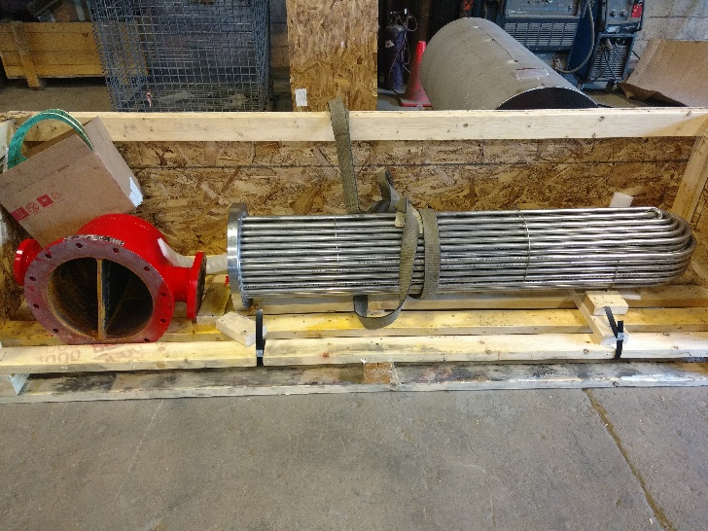
In the case of a CANDU nuclear reactor specifically, the majority of necessary heat transfer occurs within the heat transport system. There are 4 steam generators that all contain a heat exchanger. These heat exchangers are comprised of numerous “U” shaped tubes to increase surface area for maximum heat transfer.
Fig 1 – Simple Heat Exchanger.
This follows directly from Newton’s Law of Cooling where A is the surface area, ΔT is the change in temperature, h is the heat transfer coefficient, and q is the heat flux.

$\frac{dq}{dt}=hA∆T$ (1)
The difficulty in CANDU reactors is that the ΔT and A terms are fixed. To increase the heat flux, the heat transfer coefficient must be increased. Using a fundamental approach which relates momentum transfer of a turbulent fluid to the heat flux is known as the Reynolds Analogy
$\frac{τ_{w}}{ρV^{2}}= \frac{Nu}{RePr}$ (2)
The more turbulent the fluid is, or the larger the Reynolds number ($Re= ρVD/µ)$ the larger the shear stress (τ_{w}) will be at the wall of the tube. This causes more heat to flow across the material boundary. This is especially important when considering the Nusselt number ($Nu=hl/k)$ as this dimensionless number relates the amount of heat transfer to both Re and the Prandtl number ($\operatorname{Pr}{= µ\frac{Cp}{k}=\frac{ν}{α})}$. Pr is a relation between momentum diffusivity and thermal diffusivity.
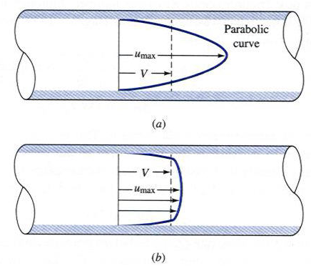
Looking at the difference between a fully developed laminar flow (Re < 2000) and a fully developed turbulent flow will show the reason for larger heat transfer

Fig 2 – Laminar (a) vs. turbulent (b) velocity profile [1].
The turbulent flow is more “flattened” compared to the parabolic laminar flow due to the higher τ_{w}. This causes more fluid particles to impact the wall transferring momentum.
A secondary way to approach this problem is to increase the friction factor (f) in the piping. Friction factor is a function of the Reynolds number as well as the relative roughness in the pipe. Relative roughness (ε/D) is the ratio of the average height irregularities in the pipe and the overall pipe diameter.
Directly increasing the friction factor does have some drawbacks as the major head loss in a piping network is directly coupled to the friction factor.
$h_{major}= \frac{fl}{D}\frac{1}{2}ρV^{2}$ (3)
Even though increasing f would increase the heat transfer, a real engineering challenge is met in that it may cause the pumps not to be able to supply enough pressure and there would no flow.
To overcome this obvious problem, numerous designs have been created to increase the heat transfer without deviating away from set pressure requirements. An effective and common way to achieve this is with the insertion of twisted tapes (TT) into each heat exchanger tube.

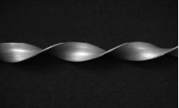

Fig 3 – Simple TT without any modifications [2].

It is possible to modify these TT’s to increase turbulence in the flow and as a result, heat transfer will increase. Multiple different modifications have been compared to see which version of a twisted tape is the most effective if utilized in a CANDU reactor.
COMPARISON
If in the event that a steam generator is disabled to be cleaned or have a component fixed, it may be worthwhile to install TT in the heat exchanger. This may delay the aging cycle of the steam generator allowing for prolonged operations. Knowing the limitations of each insert will help the engineer select an insert that does not cause too much head loss as to damage the system.
Multiple insert arrangements will be compared varying from the unmodified case shown in Fig 3.

Table I – List of all various TT methods being compared
Method | Description
Simple Twisted Tape (STT) [2] | Unmodified TT, (more of less twists per length)
Dual Tape Insert [3] | Two TT inserted per tube
‘Square’ Notched tape [2] | Similar to STT with square notches
‘V’ Notched tape [4] | Similar to STT with ‘V’ shaped notches
TT with embedded nails [5] | STT modified to have nails varying through the length
Alternating clockwise (CW) & counter-clockwise (CCW) tapes [6],[7] | The direction of twisting changes every unit length.
Helically Twisted Tape (HTT) [8] | STT that is itself twisted to resemble a helical structure

As it can be seen from Table 1, there are numerous different ways to create a TT that can be inserted into the heat exchanger inside a CANDU steam generator. The primary comparison method will be based on how well each TT method increased the Nu number relative to each other. The Nu number will change based on each varrying TT. It will provide a basis for comparison as the larger the Nu value, the larger the heat transfer coefficient and such the overall amount of heat transferred.
Table II will show a Nusselt number correlation for each of the 7 selected TT designs. Since the basis of the Reynolds analogy is that the flow is turbulent, these will be plotted against a Re number range of Re = 2300 to Re = 20000. The primary flowing liquid inside the heat exchanger of a CANDU steam generator is D₂O. This will be the liquid used with following properties (ρ = 1100kg/m³, µ = 0.00125 Ns/m², α = 1.27x10⁻⁷ m²/s) which will return a Pr value of Pr = 8.95. To simplify the calculations, an assumption will be made that the D₂O is incompressable, the viscosity remains constant, and the flow is along a streamline. Pitch diameters and various ratios will also need to be considered. To simplify the calculations and remove external variability, these will be set to a value of 1 at first, and then 1.5. Of course, each individual TT configuration could be compared with various changes to the dimensions.
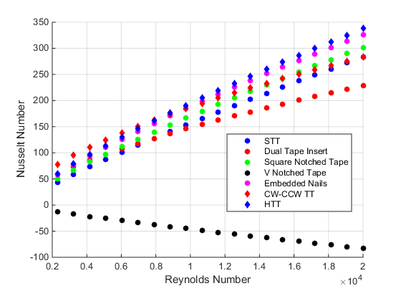
Fig 4 – Various TT Methods plotted with all geometric terms = 1. The V notched tape must require varying depth and width ratios to positivly effect the system.
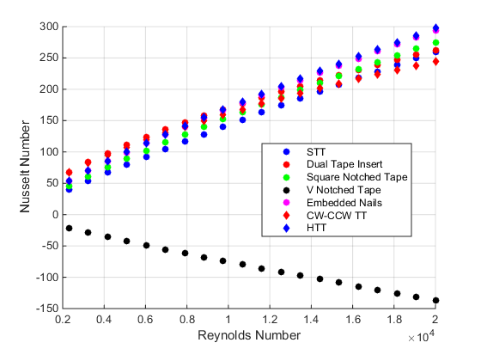
Fig 5 – Geometric terms have been set to 1.5 instead of 1.

Table II – Nusselt Number and Visual aid Comparisons for each of the Twisted Tape Inserts
Method and Visual Aid | Nusselt Number Correlation
STT (Fig 1) | Nu = 0.027Re^{0.862}Pr^{0.33}(Yª)^{-0.215} [2]
Dual Tape Insert  Fig 6.a | Nu = 0.238Re^{0.627}Pr^{0.3}(Yª)^{0.346} [3]
‘Square’ Notched Tape  Fig 6.b | Nu = 0.041Re^{0.826}Pr^{0.33}(Yª)^{-0.228} [2]
‘V’ Notched Tape  Fig 6.c | Nu = 0.0296Re^{0.853}Pr^{0.33}(Yª)^{-0.222}(1+(d/W)^{b})^{1.148}(1+(w/W)^{c})^{-0.751} [4]
TT w/ embedded nails  Fig 6.d | Nu = 0.0638Re^{0.789}Pr^{0.33}(Yª)^{-0.257} [5]
CW and CCW TT  Fig 6.e | Nu = 0.31Re^{0.6}Pr^{0.4}(Yª)^{-0.36}(1 + sinθ)^{0.44} [7]
HTT  Fig 6.f | Nu = 0.053Re^{0.796}Pr^{0.4}(Yª)^{-0.127}((p/D)^{d})^{-0.188} [8]
ª Y is defined as the twist ratio and is the number of twists within one period.
^{b} (d/W) is the depth ratio. It is the ratio between the depth of the notch to the width of the notch
^{c} (w/W) is the width ratio. This is the ratio between the width of the notch to the length of the period
_{d} (p/D) is the pitch ratio. This is the ratio between the distance between to minimum or maximum points and the diameter of the pipe

Each TT insert caused an increased Nu number as a function of Re number. For the first testing case where all geometric terms were set to 1, the HTT performed the greatest at the larger Re range. Similarly in the case with the geometric terms being 1.5, the HTT performed the best with the embedded nails tape insert very close in performance. The lower Re range also shows that the CW-CCW tape and the dual tape insert are very similar in performance. The ‘V’ notched tape shows a major decrease in Nu value. This particular tape insert requires that the geometry be in the proper ratios. If the depth ratio is 0.43, width ratio is 0.34 and the twist ratio is 2 [4]. With these dimensions, at a Re value of 11000, the Nu number would be 120 [4]. This would place this tape insert in the middle of the performance for that Re number.

CONCLUSION
Optimization is a difficult challenge when designing nuclear reactors. Most choices that benefit one aspect will harm the performance of another. In the case of the CANDU reactor, the heat transport system can be improved with the addition of twisted tape (TT) inserts into the heat exchanger tubes. Of the compared TT inserts, they all showed a positive increase in the Nusselt (Nu) value, which caused a heat transfer coefficient to also rise improving heat transfer inside the steam generator.
The Reynolds number is important to consider as it impacts which tape insert is more effective within that Re range. For lower end Re values, the dual tape insert and the clockwise/counter-clockwise tape performed the greatest. In the higher Re range, the helical twisted tape is desired.
With all of these tape inserts it is important to observe the effect they will have on the friction factor as well. If the friction factor becomes too large, the head loss in the system (3) will be more than the primary pump can supply. These tape inserts can be implemented to increase the heat transfer in a CANDU reactor increasing efficiency.

References
[1] - Sellens, Rick. "Power Law". My.me.queensu.ca., 2016. Web. 27 Nov. 2016.
[2] – P.Murugesan, K.Mayilsamy, and S.Suresh, “Turbulent Heat Transfer and Pressure Drop in Tube Fitted with Square-Cut Twisted Tape” Chinese Journal of Chemical Engineering 18(4) (2010) 609-617
[3] – P.Promvonge, S.Pethkool, M.Pimsarn, C.Thianpong, “Heat transfer augmentation in a helical-ribbed tube with double twisted tape inserts” Internation Communications in Heat and Mass Transfer 39 (2012) 953-959
[4] – P.Murugesan, K.Mayilsamy, S.Suresh, P.S.S.Srinivasan “Heat transfer and pressure drop characteristics in a circular tube fitted with and without V-cut twisted tape insert” International Communications in Heat and Mass Transfer 38 (2011) 329-334
[5] – P.Murugesan, K.Mayilsamy, S.Suresh “Heat Transfer and Friction Factor Studies in a Circular Tube Fitted with Twisted Tape Consisting of Wire-nails” Chinese Journal of Chemical Engineering 18(6) (2010) 1038-1042
[6] – K. Wongcharee, S.Elamsa-ard, “Friction and heat transfer characteristics of laminar swirl flow through tubes, inserted with alternate clockwise and counter-clockwise twisted-tapes” International Communications in Heat and Mass Transfer 38 (2011) 348-352
[7] – S.Eimsa-ard, P.Promvonge, “Performance assessment in a heat exchanger tube with alternative clockwise and counter-clockwise twisted tape inserts” International Journal of Heat and Mass Transfer 53 (2010) 1364-1372
[8] – S.Eimsa-ard, K.Yongsiri, K.Nanan, C,Thianpong, “Heat transfer augmentation by helically twisted tapes as swirl and turbulence promoters” Chemical Engineering and Processing 60 (2012) 42-48

