An Analysis of Solar Photovoltaic Energy in Canada and a Comparison to Other Developed Nations

C. Fletcher¹
¹⁾ McMaster University, 1280 Main St W, Hamilton Ontario, Canada.

(Dated: December 14, 2016)
An analysis of Solar Photovoltaic (PV) Energy around the world was undergone with the purpose of comparing Canada’s place in the world as a leader in the renewable energy of Solar PV Energy. Data from the International Renewable Energy Agency and from UNdata.org was taken for 30 developed countries (including Canada) and used to create each countries percentage of total Energy produced that is from Solar PV Energy. Canada was discovered to be one of the larger producers of energy overall, while being one of the lowest producers of Solar PV Energy on the list of developed nations. It was concluded that this might hurt Canada’s prospects as a leader in the development of new Solar PV Energy technologies.

Keywords: Climate Change, Renewable Energy, Photovoltaic (PV), Solar PV Energy, Solar Cells, Installed Solar PV Energy

Introduction
Climate Change is the biggest threat facing our planet today. Increasing world temperatures can result in many disastrous effects, including rising sea levels, heat waves, droughts and increasingly dangerous hurricanes¹. Climate change is primarily caused by Greenhouse Gasses (GHG). These GHG are produced, in part, by electricity generation. Climate change is a popular political topic, and is the leading concern of many new political parties around the world. This means that combating climate change is a subject of particular importance. Among the ways to combat climate change is using new alternative green energy sources, or renewable energy, to cut down on greenhouse gas emissions. These new ways to produce energy will not only decrease the effects that electricity generation has on climate change, but will also create new and lucrative industries around each of the technologies. One of the renewable energy technologies is Photovoltaic (PV) Solar Cells. These Solar Cells work by converting the suns light energy directly into electricity. This technology has been around since the 1950s² and has been used to power small electronics frequently, but is only recently being used on a wider scale to help power whole countries.
To capitalize on this new industry, Canada should be trying to keep up with the rest of the developed world in their use of Solar PV energy. This paper will attempt to discuss the state of PV Solar Energy as part of the larger energy profile of Canada, and compare this with the state of PV Solar Energy within other developed nations. The installed energy capacity of Solar PV Energy in Canada and other nations will be investigated and a percentage of total energy will be found. Then these percentages for each country will be compared to each other to learn where Canada stands within the world of Solar PV Energy.

Methods
To compare data from many different countries, third party sources were used. The source of data chosen was the International Renewable Energy Agency (IRENA)³. They have a lot of easy to access graphs and data that will be used to compare each countries Solar PV Energy capacity. To look at the total amount of energy capacity (renewable and non-renewable), the source of data chosen was UNdata.org⁴. UNdata is a United Nations statistical database search engine, which was used for this paper to access the Net Installed Capacity of Electric Power Plants database. Because the last year UNdata.org had was 2013, that is the year that is used in the comparisons. These two data sources were used as neither had all of the information needed to perform the comparison of multiple countries that this paper set out to. The two sources agreed on renewable energy numbers, so calculations could be performed using both sets with confidence. The data for the energy capacity of Solar PV Energy for each country was compared to the Net Installed Capacity for each country in order to acquire the percentage of the total energy capacity that PV technology holds. This percentage was then used to compare Canada against the rest of the developed world.

Results and Discussion
To begin the investigation, graphs from IRENA of the installed energy capacity of Solar PV Energy are below. To begin the investigation the installed capacity in the world is shown [Fig. 1].

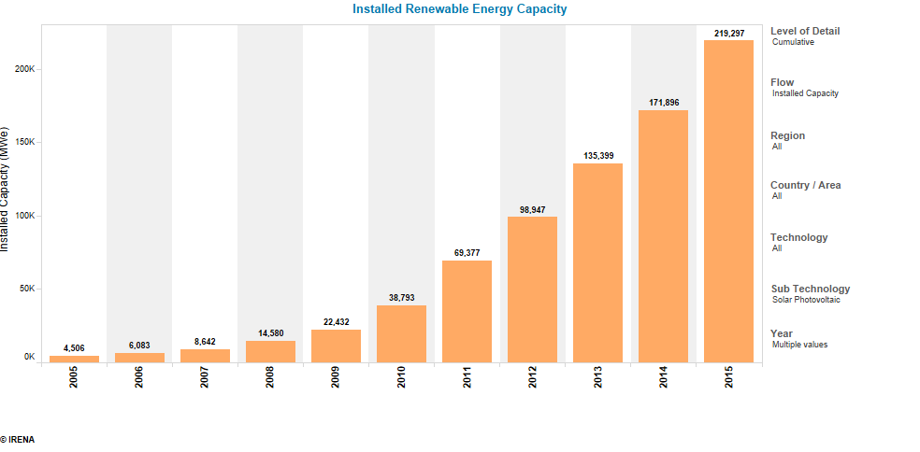Fig. 1 Total Installed Solar PV Renewable Energy Capacity Worldwide in Megawatts-electric.³
The graph above shows the installed Solar PV Energy capacity of the world. One can see that the worldwide capacity has begun to increase rapidly in the past ten years. The next graph shown will be the same graph as in Figure 1, but just for Canada [Fig. 2].
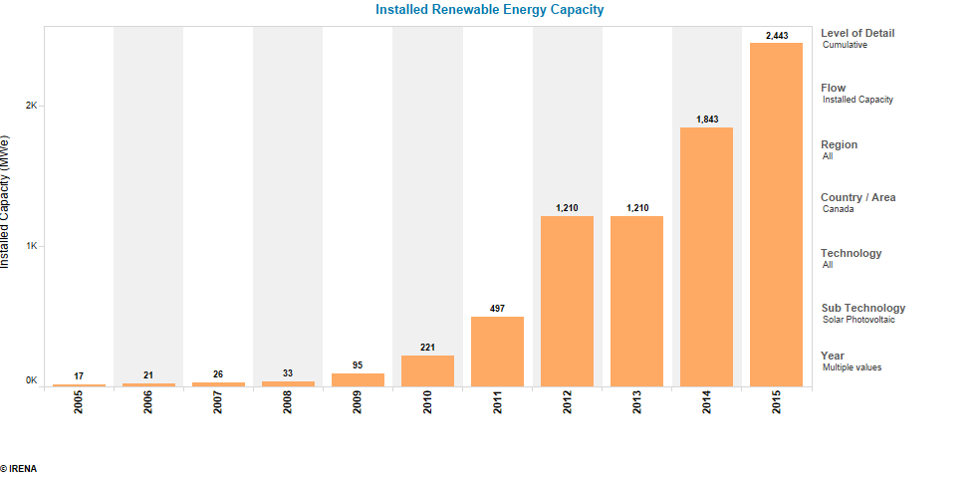
Fig. 2 Total Installed Solar PV Renewable Energy Capacity for Canada in Megawatts-electric.³
Here one can see that Solar Power capacity in Canada has also been increasing, but only for the past seven years, and that in 2013, Canada did not add any Solar PV energy capacity at all.
To look at the percentage of total energy that is Solar PV Energy, the total energy was taken from the UN database UNdata.org⁴. The graph of countries by percent of total Energy that is Solar PV [Fig. 3], contains the percentage data for 30 countries. On the left axis is the percentage of Energy that is Solar PV of that Country’s total installed energy. The countries are ordered from least amount of total installed energy to most installed energy. From [Fig. 3] one can see that Canada is the 6th largest Energy producer on the list. This means that Canada could be one of the bigger polluters when it comes to pollution from non-renewable energy resources. It should be in Canada’s interests then, to try to use as many renewable energy sources as possible, such as Solar PV Energy. From [Fig. 4], one can see that Canada is 9th from the bottom on this list of developed countries. This shows that Canada is far behind most other developed countries in Solar PV Energy. When it comes to the development of new technology to lead this renewable energy source, the Canadian government will not put as much research money into the industry, as it would have the least to gain from advances in technology due to not relying on Solar Energy as much as the other developed nations.
Fig. 3 Graph of Countries with the percentage of total installed Energy that is Solar PV Energy. Countries sorted by Total Energy produced
This paper is limited in some ways. It only uses the year 2013 as that was the latest year that all needed data for multiple counties could be acquired. This is limiting because of the rapid and recent explosion in Solar PV energy in all developed countries [Fig. 1]. The paper also does not take into account the fact that certain areas of the globe might be better for Solar PV than others. This could affect a country’s ability to use Solar Energy, and influence them to use other sources of renewable energy.
Further research should be done on topics such as the correlation between government investment into Solar Energy technologies, and the potential for solar power around the globe. This would allow for my study to be taken in context of what countries spend the most of Solar PV research, and what countries have the most potential for Solar Energy production.

Conclusion
In conclusion, a list of 30 developed countries was developed, and their percentage of total energy that is Solar PV Energy was calculated from data from IRENA and from UNdata.org. It was discovered that Canada is the 6th highest energy producer on the list of 30 developed countries. This means that Canada should have a large interest in keeping their Energy sources as clean as possible by using renewable energy technology such as Solar PV. It was then found that Canada falls below the average on the percentage of Solar PV energy that it uses. The paper then discussed how this could mean that the Canadian government does not value Solar PV energy as much as other governments, and that as a result, Canada would be less incentivised to provide research money for Solar PV technologies. Further research was suggested in fields of country by country Solar PV research, and country potential for Solar Energy, that would further the understanding of the worldwide Solar Industry.

References
Fig. 4 Graph of Countries with the percentage of total installed energy that is Solar PV energy. Countries sorted by their percentage.
¹ Earth Science Communications Team at NASA's Jet Propulsion Laboratory, http://climate.nasa.gov/effects/
² A. Goetzberger Fraunhofer Institut for Solar Energy Systems,Germany, http://indico.ictp.it/event/a04253/session/7/contribution/4/material/0/0.pdf
³ International Renewable Energy Agency, Capacity and Generation, Statistics Time Series, http://resourceirena.irena.org/gateway/dashboard/?topic=4&subTopic=16
⁴ UNdata.org United Nations Statistics Division, Electricity, net installed capacity of electric power plants, Energy Statistics Database, http://data.un.org/Data.aspx?d=EDATA&f=cmID%3AEC

