Artist and Father of Modern Neuroscience: Who Was Santiago Ramon y Cajal?

Childhood
Santiago Ramon y Cajal was born on May 1, 1852, in the town of Petilla de Aragón in northern Spain.¹ As a child, Cajal was very mischievous. His father, a surgeon and professor of applied anatomy, had Cajal attend several schools, in hopes that he would learn to behave cordially.² However, Cajal was averse to the harsh discipline of the monks that taught at his school; he had a gift for drawing but was a reluctant pupil in other subjects. A prime example of his headstrong and rebellious nature was his imprisonment at age 11, for destroying his town’s gate with a homemade cannon.¹ Cajal’s father, ultimately losing patience with his son, withdrew Cajal from school and apprenticed him first to a barber and then to a cobbler.² However, Cajal insisted on pursuing drawing. His father confiscated his brushes and sent him to a strict Jesuit secondary school.¹ Seeing his son’s insistence on pursuing art, Cajal’s father later took him to graveyards where he could study and draw the bones of ancient burials. Through this, he aimed to steer his son toward an interest in learning about anatomy.³

Medical Education
His father’s persuasion worked, and Cajal later enrolled to study medicine at the University of Saragossa.² In 1872, at age 21, Cajal took the Licentiate in Medicine at Saragossa and became qualified to practice medicine. He passed a competitive examination and soon began serving as an army doctor.² Upon contracting malaria and tuberculosis during his expeditions to Cuba, Cajal was posted back to Spain. There, he spent time in the care of his mother and sisters near the Pyrenees mountains.³ After his recovery, Cajal went to Madrid to work on his doctorate, where he met professor Aureliano Maestre de Jan Juan, the first chair of histology and pathology, and Spanish neurologist Luis Simarro.^{4,5} It was at Simarro’s laboratory that Cajal first discovered slides of nervous tissue treated with the Reazione Nera (The Black Reaction), a technique developed by biologist and pathologist Camillo Golgi.⁶ Cajal began experimenting with The Black Reaction and modified it to better explore the fine structures of the central nervous system.

The Black Reaction is a silver staining technique used to visualize nervous tissue under light microscopy and is now more commonly known as the Golgi Stain.⁵ Camillo Golgi discovered that silver nitrate and potassium dichromate together fixed particles of silver chromate to the membranes of nerve cells, making them dark and visible against a yellow background.⁷ This staining method permitted neurons to be seen in their entirety and with acuity. Cajal refined this technique by using higher concentrations of the chemicals, introducing silver nitrate to the tissue in two shorter soaks rather than one long soak, and using thicker sections of neurons to study under the microscope.⁸ Cajal found that this method worked best on neurons with myelinated axons, making birds and mammal embryos ideal for his work.⁴ Despite his ground-breaking research being in the field of neuroscience, Cajal's artistic vision played a significant role in his scientific papers and discoveries. He felt that the most essential quality of a scientist was “the ability to see clearly.”⁹

Research and Discoveries
Within a year of his research, Cajal made the pioneering discovery that the nervous system in birds was made of individual cells that displayed connections with one another. Coined as the neuron doctrine, Cajal's work established that neurons, the basic unit of the nervous system, are discrete, individualized, and separate cells with processes arising out of the cell body.¹⁰ Cajal represented his findings in drawings such as Figure. 1, using materials such as Indian ink, pencil, and oil, as well as white wax for corrections.¹¹ Other scientists examining similar preparations believed that the observed tangle of continuous fibers transmitted nervous energy in the brain similar to vibrations through a spiderweb.¹¹ However, Cajal observed with a keen eye the form and function of these discrete neurons. Through his observations, he concluded that nervous signals must enter and exit the neuron through separate points; the dendrite and axon, and must pass electrical information in one direction. He also understood that information was transmitted from one cell to the other over a minuscule gap known as the synapse. Since this gap was too small to be observed under the light microscope, Golgi, who invented the silver nitrate stain, dismissed Cajal's neuron doctrine.¹¹ Golgi, along with other notable scientists, believed that neurons formed a linked network and behaved as a single entity. ¹¹ It was only when these cells were observed under an electron microscope that the relationship Cajal had mapped in thousands of elegant drawings was officially confirmed. In 1906, The Nobel Prize committee decided that both Cajal and Golgi would share the Nobel Prize for Medicine/Physiology, despite the dichotomic and contrasting views of the two scientists.² Cajal referred to this “pairing of scientific adversaries of such a contrasting character” as a “cruel irony of fate.”³ He stated, however, that the other half of this award was “very rightly awarded to the illustrious professor of Pavia, Camillo Golgi, the inventor of the method with which [he] accomplished [his] most striking discoveries.”³
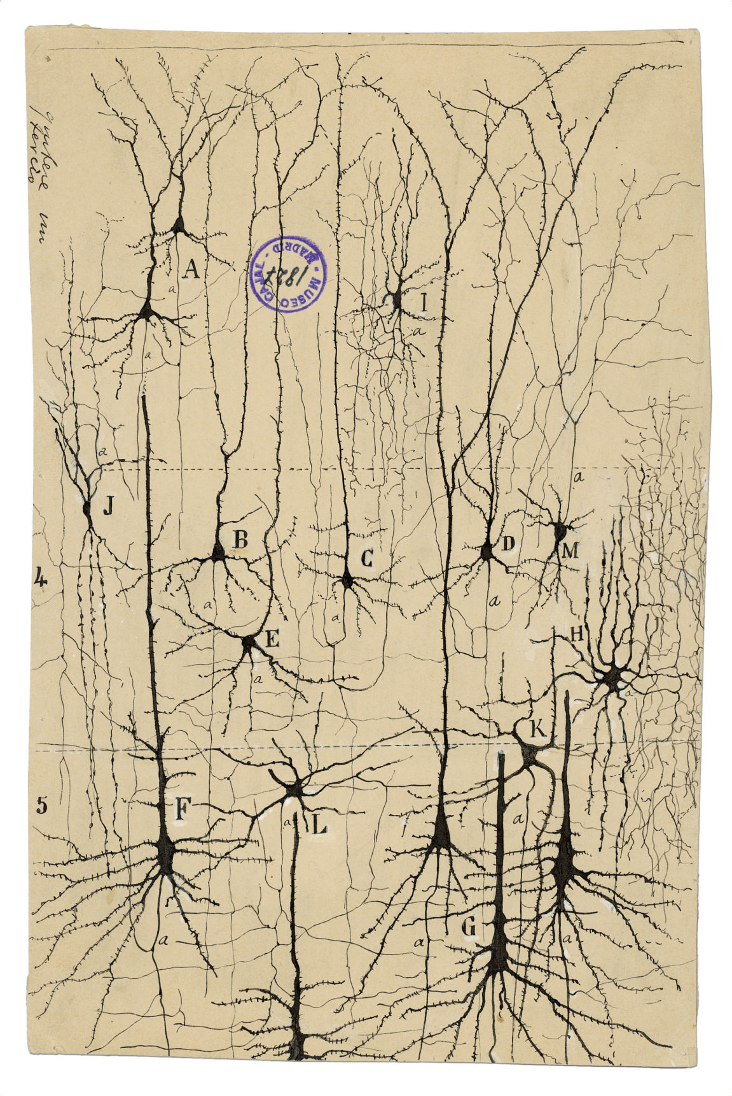

Figure 1. Cajal’s graceful depiction of neurons as discrete, individualized cells. Using The Black Reaction technique pioneered by Golgi, Cajal noted that cells in the nervous system had free nerve endings apposing different neuronal cell types, suggesting that each nerve cell was a distinct unit. Despite the variation in size and position, the pyramidal cells (a,b,c,d,e,f,g,h) depicted in this drawing all exhibit the characteristic cone-shaped cell body, a single apical dendrite extending upwards to the cortical surface, basal dendrites, and basal axons.⁵

Cajal's passion and interest in the arts influenced his approach to his future scientific investigations. By dissecting cadavers with his father, anatomy became an engaging visual experience for him. After his experience refining Golgi’s silver nitrate stain, Cajal went on to develop a gold stain in 1913, which helped him study the fine structures of nervous tissue in the brain, sensory centers, and spinal cords of embryos and young animals.³ Gold staining specifically targeted astrocytes in white matter, as well as those in gray matter, which was difficult to observe. These nerve-specific stains enabled Cajal to differentiate neurons from other cells and examine the structure and connections of nerve cells in gray matter and the spinal cord.¹² These stains were of great value in the diagnosis of brain tumors, with Cajal’s scientific drawings continuing to illustrate neuroscience textbooks today.

References

- Abbott A. Santiago Ramón y Cajal: art, politics and neuroscience revolution. Nature. 2022 May 26;605(7911):613–4.
- Bentivoglio, Marina. “The Nobel Prize in Physiology or Medicine 1906.” NobelPrize.org, April 20, 1998. https://www.nobelprize.org/prizes/medicine/1906/cajal/article/.
- de Castro F. Cajal and the Spanish Neurological School: Neuroscience Would Have Been a Different Story Without Them. Front Cell Neurosci. 2019 May 24;13:187.
- De Carlos JA, Pedraza M. Santiago Ramón y Cajal: The Cajal Institute and the Spanish Histological School: Santiago RamÓn y Cajal. Anat Rec. 2014 Oct;297(10):1785–802.
- O'Neil E, Taddeo S. Golgi Staining Technique [Internet]. The Embryo Project Encyclopedia. 2017 [cited 2022 Dec 4]. Available from: https://embryo.asu.edu/pages/golgi-staining-technique
- Turner R, De Haan D. Bridging the gap between system and cell: The role of ultra-high field MRI in human neuroscience. In: Progress in Brain Research [Internet]. Elsevier; 2017 [cited 2022 Dec 4]. p. 179–220. Available from: https://linkinghub.elsevier.com/retrieve/pii/S0079612317300493
- Stewart D. Santiago Ramón y Cajal [Internet]. Famous Scientists. 2022 [cited 2022 Dec 4]. Available from: https://www.famousscientists.org/santiago-ramon-y-cajal/
- Santiago Ramón y Cajal [Internet]. New World Encyclopedia. 2022 [cited 2022 Dec 4]. Available from: https://www.newworldencyclopedia.org/entry/Santiago_Ramón_y_Cajal
- Kugler J. Santiago Ramón y Cajal Exhibit - office of NIH history and Stetten Museum [Internet]. National Institutes of Health. U.S. Department of Health and Human Services; [cited 2022 Dec 4]. Available from: https://history.nih.gov/pages/viewpage.action?pageId=1016727
- Garcia-Lopez P, Garcia-Marin V, Freire M. The histological slides and drawings of Cajal. Front Neuroanat. 2010;4:9.
- Fields RD. Why the first drawings of neurons were defaced [Internet]. Quanta Magazine. 2019 [cited 2022 Dec 4]. Available from: https://www.quantamagazine.org/why-the-first-drawings-of-neurons-were-defaced-20170928/
- Santiago Ramón y Cajal [Internet]. Encyclopaedia Britannica. 2022 [cited 2022 Dec 4]. Available from: https://www.britannica.com/biography/Santiago-Ramon-y-Cajal

